

**Director of Annual Giving**

Thacher School

Ojai, California

Thacher is one of the most selective and highly regarded boarding schools in the nation. Founded in 1889 by Sherman Day Thacher, the School serves academically talented students from 24 states and 11 countries in a rigorous college preparatory experience. The faculty and students live and work closely together on a 427-acre campus nestled in the foothills of the Los Padres National Forest in Ojai, California (85 miles north of Los Angeles). Honor, fairness, kindness, and truth are the cornerstones of School life. Together, we commit to the belief that demands in the academic classroom, when combined with those of mountains and horses, of sports and the arts, produce independent minds, strong bodies, and powerful character. The School enrolls 260 students, has an operating budget of $20 million, and an endowment of $150 million.

Thacher has a solid track record of fundraising. In 2008, the School completed an $81 million Campaign for Thacher primarily targeted on completing an aggressive capital building program: adding two new dorms, a performing arts center, student commons, all-weather track, a new field, and weight room. We are currently in the public phase of a $160M Capital Campaign, that is projected to end in 2020.  Our annual giving and events programs are very strong with over 55 percent of alumni supporting the school every year and attendance at Reunion, Alumni Day, Family Weekends, and regional gatherings are consistently filled to capacity.

**Director of Annual Giving**

The Director of Annual Giving is responsible for the design, strategy and implementation of The Thacher School’s Annual Fund. The Director of Annual Giving will work closely with key staff, trustees and other volunteers to identify, cultivate, solicit, and steward Thacher’s key constituencies, including the Thacher alumni, current parents, parents of alumni and friends, and grandparents. The Director will continue to lead short term strategies as well as the long-term vision for one of the nation’s highest performing annual fund programs.

Additionally, the Director of Annual Giving leads the Annual Fund Team, which is responsible for developing sustainable and creative solutions to meet the growing needs of the diverse Thacher community. The Director works closely with the Alumni Relations team to sustain and grow the support from and the connection between our alumni and The Thacher School. This position reports to the Director of Advancement.



**Major Functions and Responsibilities:**

* Develop, manage and implement an annual fund development plan including all goals, objectives and tasks for the Annual Fund team.
* Manage Annual Giving team and create annual budget.
* Determine annual giving goals by constituent groups and strategy.
* Work effectively with the major gifts and campaign teams to build strategies for moving donors to higher giving levels.
* Develop annual giving communications strategy by method and constituency to achieve maximum ROI.
* Report to the Development Committee and the Board of Trustees
* Manage a prospect pool with annual goals for personal visits and advancing relationships. Solicit leadership annual fund gifts ($5,000 - $100,000).
* Develop and manage metrics to measure the effectiveness of annual strategies.
* Oversee all reunion giving activities as well as the execution of the 30th - 75th reunions
* Manage with Stewardship Manager annual recognition efforts and stewardship opportunities such as the Annual Donor Report (online and print)
* Coordinate Leadership Dinner and other annual giving stewardship events in tandem with Thacher’s stewardship program.
* Develop and execute a highly effective and sustainable volunteer component (Class Reps/Class Agents) within annual giving.
* Work with the School including current faculty, staff and students to educate and grow participation in the Annual Fund.

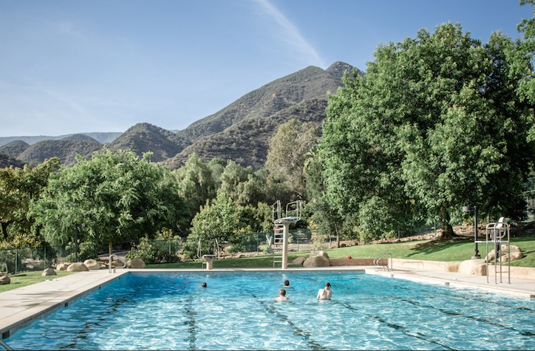

**Qualifications:**

* Bachelor’s degree required.
* Five years of fundraising and/or educational experience required.
* Strong managerial, leadership and supervisory skills necessary.
* Demonstrated organizational and communication skills as well as ability to work with and motivate other development professionals and volunteers.
* Ability to work independently and cooperatively within a team environment.
* Willingness and ability to travel and to work nights and weekends, as required.
* Understanding of database management, gift processing and donor relations.
* Openness to new ideas and their implementation. Ability to react and adapt to changing situations appropriately.
* Demonstrated analytical and fund raising skills with the ability to recognize opportunities, identify critical, high pay-off activities and prioritize them to attain goals.   
  Ability and interest in managing, developing, motivating, and mentoring staff.
* Ability to establish rapport quickly with donors.
* Familiarity with boarding school culture a plus and willingness to be a part of a close-knit community



**Compensation and Benefits:**

Compensation dependent on experience. The Thacher School offers competitive salaries and an excellent benefits package. In addition to meaningful and rewarding work, Thacher provides an excellent compensation and benefits package including medical, dental, life & long-term disability insurance, a generous retirement program, and paid time off.

**Interested Persons Contact:**

Jonathan K. Ball

Managing Associate

Carney, Sandoe & Associates

617-933-3450 (dir)

[*jball@carneysandoe.com*](mailto:jball@carneysandoe.com)

*All inquiries and nominations are kept confidential.*

*Thacher School does not discriminate on the basis of age, gender, religion, race, color, sexual orientation, gender identity, genetic information, disability, or national or ancestral origin in the administration of its educational policies, scholarship and loan programs, athletic and other School-administered programs, or in the administration of its hiring and employment practices. The above information on this description has been designed to indicate the general nature and level of work performed by employees within this classification. It is not designed to contain or be interpreted as a comprehensive inventory of all duties, responsibilities, and qualifications required of employees assigned to this job.*